RESOLUTION NO.__________

RE: CERTIFICATE OF APPROPRIATENESS UNDER THE
PROVISIONS OF THE ACT OF THE PENNSYLVANIA
LEGISLATURE 1961, JUNE 13, P.L. 282 (53
SECTION 8004) AND BETHLEHEM ORDINANCE NO.
3952 AS AMENDED.

WHEREAS, it is proposed to modify the previously approved facade renovations at 226 E. 3rd St.

NOW, THEREFORE, BE IT RESOLVED by the Council of the City of Bethlehem that a Certificate of Appropriateness is hereby granted for the work.

Sponsored by: (s)

(s)

ADOPTED BY COUNCIL THIS DAY OF

(s)
President of Council

ATTEST:

(s)
City Clerk

HISTORIC CONSERVATION COMMISSION

CASE # 453 – It is proposed to modify the previously approved facade renovations at 226 E. 3rd St.
OWNER/APPLICANT: Alejandrino & Carmen Trujilo / Kevin Luna

The Commission upon motion by Mr. Evans seconded by Mr. Loush adopted the proposal that City Council issue a Certificate of Appropriateness for the proposed work described herein:

- The proposal to modify the previously approved facade renovations at 226 E. 3rd St. was presented by Kevin Luna. .

- Instead of an arched parapet in the center of the façade it will have a more traditional rectilinear profile as shown in the new renderings.

- The tall parapet wall above the entrance to the basement level may be removed.

- The raised rectilinear parapet will be located at the approximate center of the long wall of the façade and centered on the support pier between the windows.

- The low knee wall and support piers between the storefront windows will be clad in stone tiles as previously approved and not aluminum panels. Shop drawings showing typical jointing patterns, returns, and corner details must be submitted for review by the Historic Officer.

- The 3 oval signs will be changed to rectangular signs. The signs will have pin-mounted letters that may be back lit to provide illumination. Shop drawings for the back-lit illuminated signs must be submitted for review by the Historic Officer.

- The nine small individual signs previously approved may be changed to four larger signs. The signs may be externally illuminated with no more than 5 gooseneck light fixtures.

- There will be no E.I.F.S. used on the project except for the molding at the top of the façade.

- The new stucco must be a cement based stucco system. The top coat may be acrylic stucco with integral color.

- The proposed roof (awning) at the rear corner of the building must be reviewed by the HCC at a future meeting.

- The new paints colors are historically appropriate and recommended.

- The proposed motion was unanimously approved.

CU: cu

By: 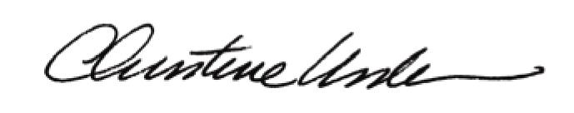

Date of Meeting: May 20, 2013 Title: Historic Officer

